Altering the urban development matrix: From pilots to policy
Over the past 14 years, The alliance of the Zimbabwe Homeless People’s Federation and its technical partner, Dialogue on Shelter has pioneered a multiplicity of alternative development options. These alternatives have been implemented in various towns and cities with a view of providing affordable options for the urban poor in their human settlements endeavors. The ten-year recession that Zimbabwe went through from 1998 - 2008, did not spare the urban poor in their struggle for secure tenure. In fact, the challenges for the urban poor mounted culminating with Operation Murambatsvina in the winter of 2005. In the latter, according to UNHabitat 700 000 urbanites were displaced due to nation-wide evictions which were launched by government in a bid to ‘clean’ the cities. On the other hand, local authorities were inundated with ballooning housing waiting lists with the official list for Harare reaching 500 000 in 2010. Meanwhile, restrictive urban legislation that are inconsistent with economic realities have even further undermined the capacity of already financially hamstrung city administrations.

It is against the above background that the alliance of Zimbabwe Homeless People’s Federation and Dialogue on Shelter have implemented pilots across the country geared towards demonstrating development alternatives that can be scaled up and meaningfully contribute towards addressing the housing backlog. As may have been expected, charting this new development trajectory has not been an easy stroll in the park and in some instances resulting in fierce contest of ideas between the alliance and some officials that are opposed to altering the existing urban development matrix. However, thankfully the journey has also not been without partners as some local authorities have been very supportive of piloting new alternatives around housing and infrastructure development. To this end, many local authorities have created space to test new ideas through a number of precedent-setting pilots. Notable examples include Harare City Council, Bulawayo City Council, Kariba Municipality, Chinhoyi Municipality, Mutare City Council and Victoria Falls Municipality to name but a few. In Victoria Falls, for instance, the local authority is amongst the first councils to allow community-driven infrastructure installation on a massive scale (nearly 600 stands) under a project in Nkosana Township. This shift followed an exchange visit in 2001 to the famous Orangi Pilot Project [OPP] in Pakistan. Victoria Falls was soon followed by Mutare City Council which again accepted the idea of community-led infrastructure development in Dangamvura under a project with 1400 plots in 2005. However, in recent years, emphasis has changed from conventional infrastructure to innovative ways of supplying the basic services. It is this new focus that has seen the pioneering work around ecological sanitation toilets popularly known as eco-san. The latter has a number of variations and functions on the basis of two principles; 1) the ecosan technology [sky-loo] separates fecal waste from urine, 2) ecosan concept has a suspended vaults hence does not require digging of a pit, and 3) eco-san toilets users pour a handful of ash or lime after every use to catalyze decomposition and prevent unpleasant smell. Such toilets have been built with full support of the Councils in areas like Chinhoyi, Bulawayo, Dete and Harare after a series of exchanges with the Malawi Homeless People’s Federation. In Chinhoyi, for example, 150 ecosan toilets and 3 boreholes for 244 Federation families and those from surrounding communities have been installed by the Federation as a sustainable alternative prior to the provision of reticulated infrastructure. Besides the buy-in from Councils, the harsh realities of perennial water cuts in many cities and towns have also naturally eased the switch to new alternatives. On the other hand, in Harare 3 boreholes and 130 ecosan toilets [communal and individual] have so far been built for an estimated 474 households. In Epworth, the upgrading of slums with a total population of 6300 families has paved way for in-situ slum upgrading as a sustainable solution as opposed to evictions.
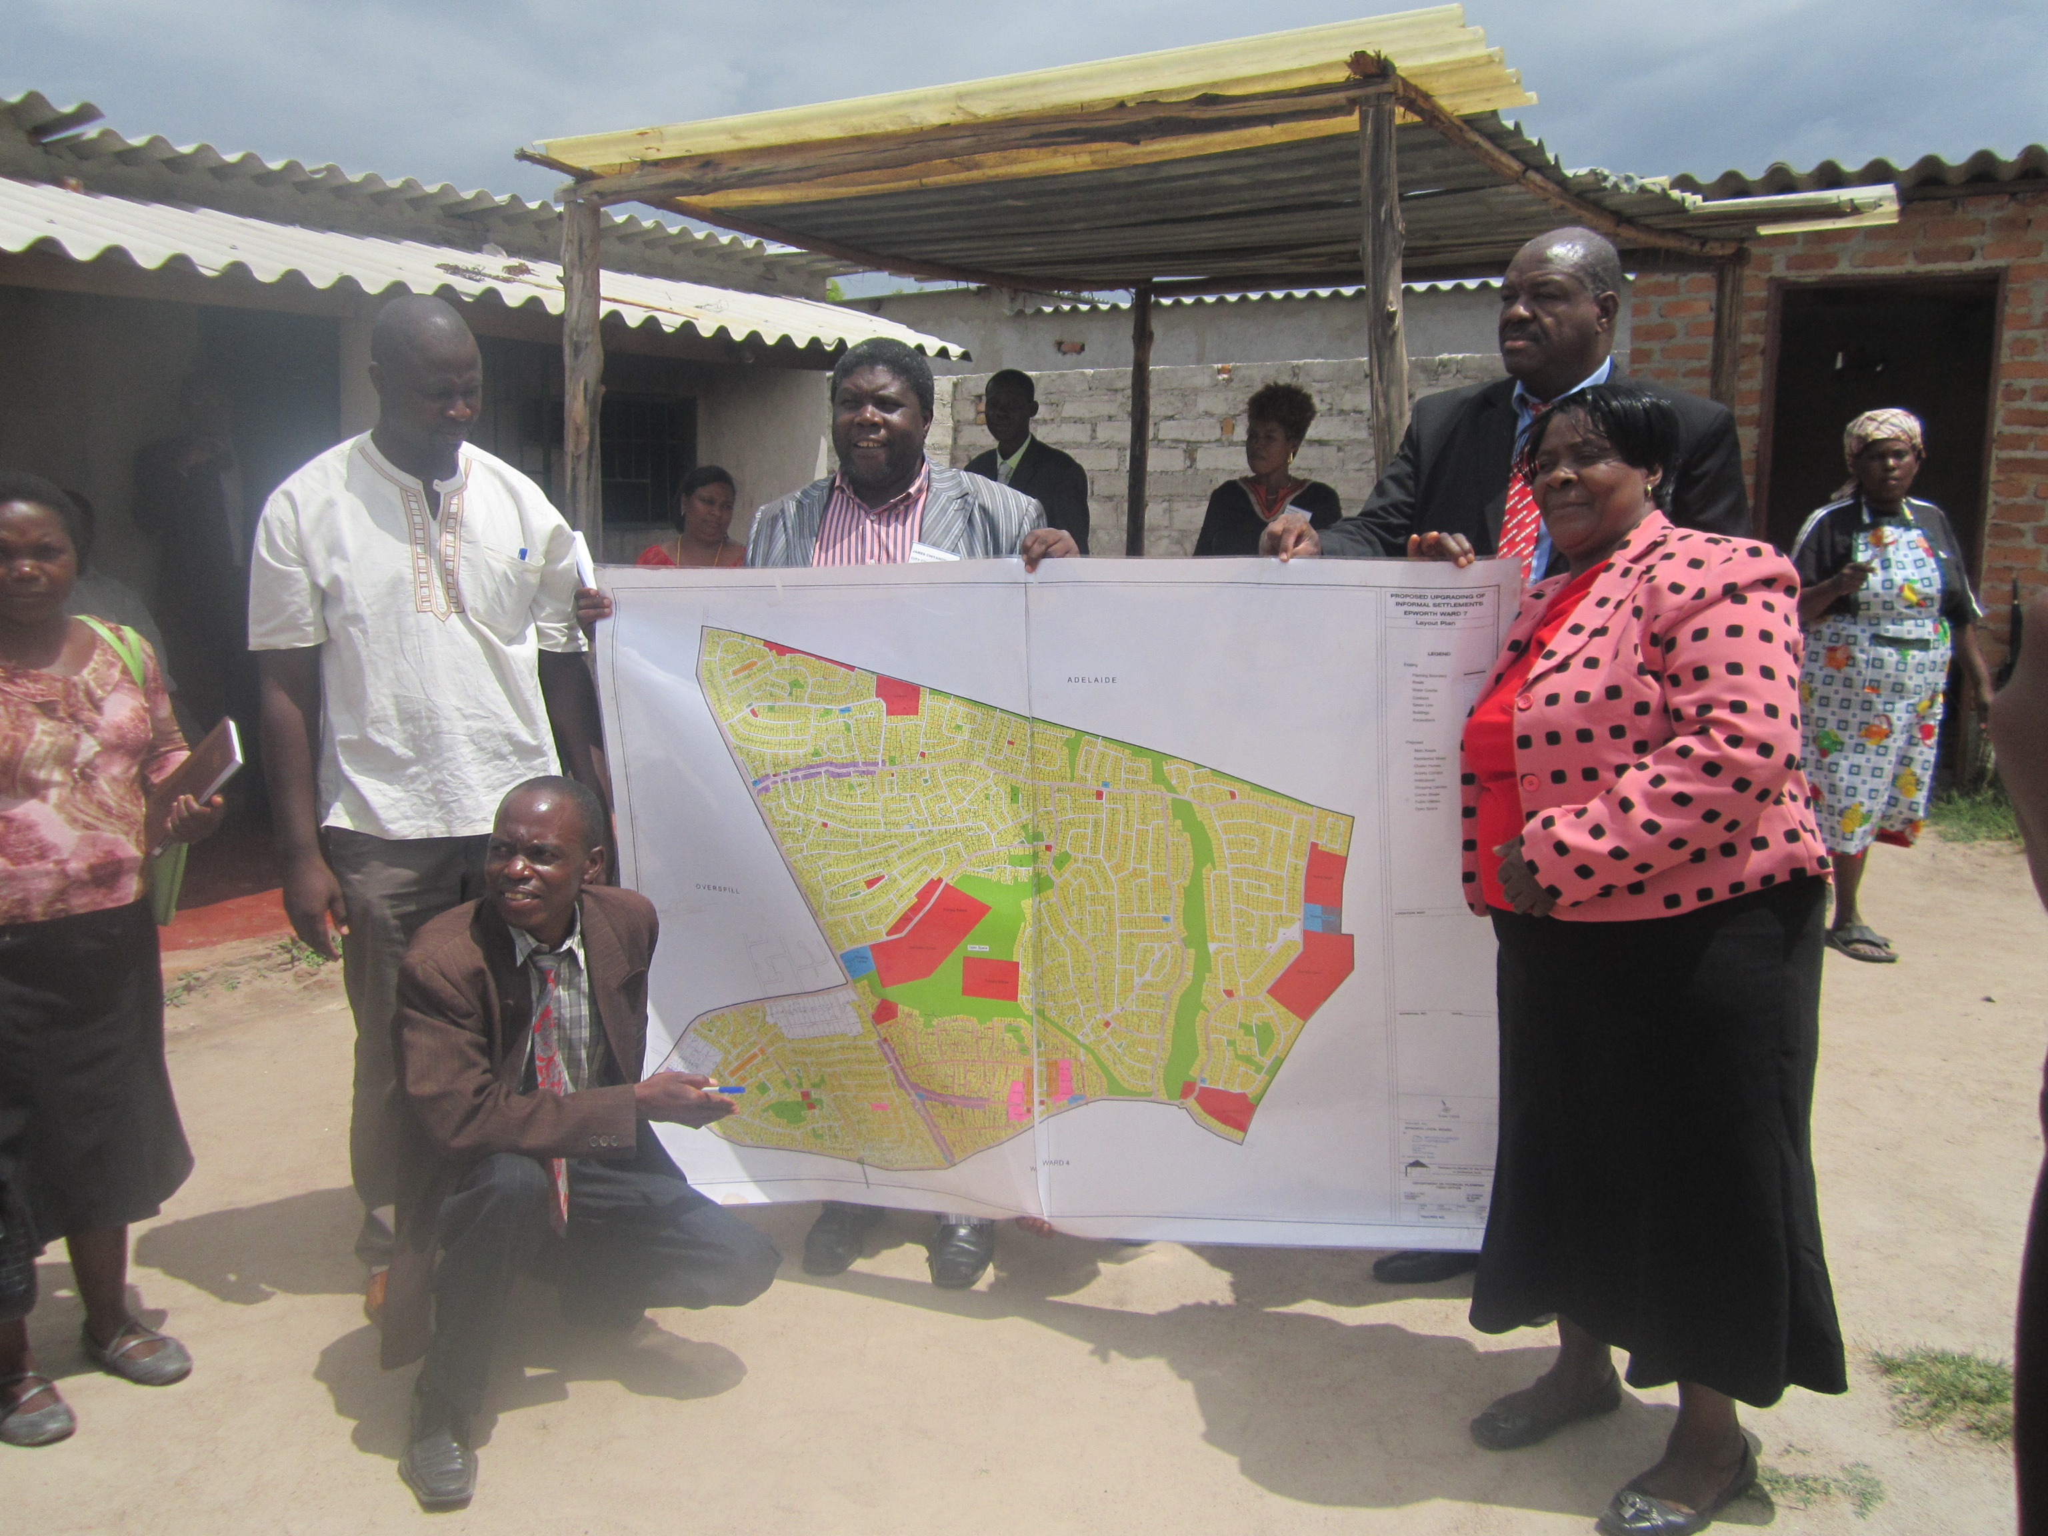

Whilst these experiments represent significant inroads in terms of pioneering new ways of managing urban development, there is need to ensure that these achievements are grounded in policy. The dialogue around alternatives has to be elevated to a higher level. Pilot projects need to be transformed and institutionalized into policy. That way, the scope for replicating such projects on a bigger scale is enhanced. In Chinhoyi, such initiatives have already begun in earnest with a multi-stakeholder dialogue session on water and sanitation have been conducted earlier this year. In Harare, the review of building regulations being undertaken under the Harare Slum Upgrading Projects presents a perfect opportunity to revisit urban policies. At the national level, government has also embraced incremental development in the revised National Housing Policy a very significant milestone towards changing the traditional urban development practices.

